Text for Parish Councils and district councils to put in their individual newsletters/websites

Have you had your say on Lancashire's roads?

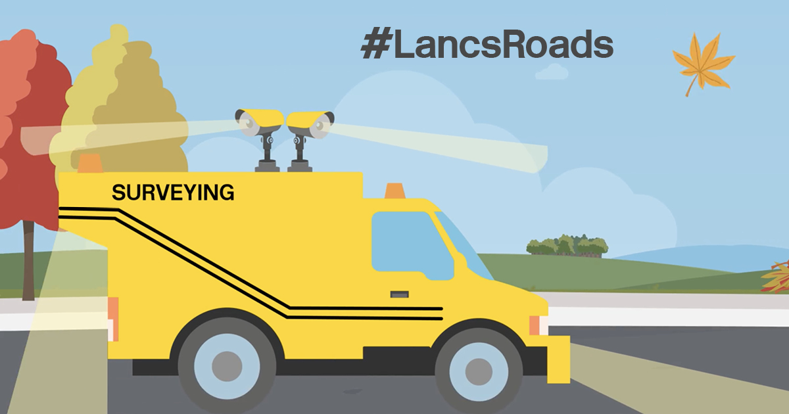
Lancashire County Council is asking for residents' views on Lancashire's highways and transport services – from the condition of roads and footpaths to the quality of cycling facilities.
The council's highways team are encouraging people to complete the National Highways and Transport (NHT) survey, which measures public satisfaction with services across different local authorities. You can have your say on your roads and transport locally by completing the short survey.
The results will be compared with the views of other members of the public across 111 local authorities in England & Scotland. It will help the county council make future decisions on where to prioritise their resources, share best practice and identify further opportunities to work with other authorities in the future.
This year, the council have made marked improvements to reduce the impact of their work on the environment and are set to achieve a 15% carbon saving in our carriageway capital programme. They recently received a national award in recognition of their Highways Decarbonisation Strategy, which includes the use new lower carbon materials and techniques for road maintenance.
Find out more about how the team are working hard to improve Lancashire's roads and complete the survey at Road maintenance - Lancashire County Council

Example social media post for parish councils and other stakeholders to use on their social media accounts
Have you had your say on #LancsRoads and completed the National Highways and Transport (NHT) survey?
@lancashirecc is asking for residents' views on their highways and transport services – from the condition of roads and footpaths to the quality of cycling facilities.
The results will be compared with the views of other members of the public across 111 local authorities in England & Scotland to help them make future decisions on where they prioritise resources.
Complete the survey at https://www.nhtnetwork.co.uk/isolated/data/scorecard/new/bespoke/122

